Stardom and Performance in Postwar Italian Cinema 1945-54.
Symposium held at the University of Turin, 17-18 May 2018.
In association with the Centro Ricerche Attore e Divismo, Università di Torino, and the British Academy.
Keynote speaker: Professor Stephen Gundle (University of Warwick)
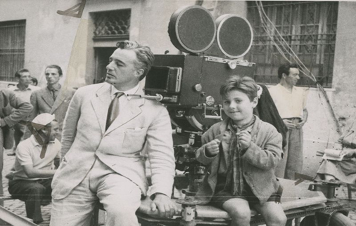
Call for Papers
Italian postwar cinema has been much studied and celebrated as the highpoint of Italy’s cinematic production, with neorealist films such as Rome, Open City (1945), Paisan (1946), Shoeshine (1946), and Bicycle Thieves (1948) winning Oscars and achieving international acclaim. New books continue to appear on this immensely influential moment, but, strangely, there has been relatively little interest in the dynamics of acting, performance, and stardom that constitute one of the period’s most distinctive features. In particular, neorealism’s use of non-professional actors, including children and GIs, means that it is often viewed as anti-star; however, the complex interactions within Italian postwar cinema between stardom and non-professionals, and its ‘amalgam’ (Bazin, 1948) of stars and non-actors have been neglected.
This symposium aims to bring together scholars working on acting, performance, and stardom in postwar Italian cinema in order to critically re-evaluate this moment in Italian film history, and to give a richer picture of both the figures of the actor and the non-actor.

The symposium invites papers that investigate the following questions:

- What is the economic and symbolic value of the non-actor: how can we conceptualise the cultural investment in the non-professional, which has its roots in the neorealist period, but whose ‘bodily contingency’ (Schoonover, 2012) has enduring value in world cinema?

- How can we theorise the ‘amalgam’ of stars and non-professionals: when they perform together, how are our conceptions of their personae changed?

- How does the use of non-professionals change the audience’s relationship with films? Does it induce a closer sense of proximity to the on-screen figures?

- How can study of casting processes, recruitment, and actors’ contracts illuminate the significance of the non-professional in the economy of cinema and in the Italian national imaginary?

- What can Italian press discourse of the time, especially as related to the ‘crisis’ of acting, tell us about the currency of actors and stars in the postwar period?

- What is the role of institutions such as acting schools, press, and film festivals in shaping dominant views of the actor in the period?

- How can an expanded definition of performance (understood broadly as
speech, movement, gesture, non-verbal utterances, singing, dancing, as well as interactions with the public and press) cast light on our understanding of acting and non-acting?

- Neorealist films’ focus on the child has principally been understood as
metaphor for Italy’s future. How can studying the child as labourer and as
performer take us beyond this conception of the child as mere symbol?

- How is the child directed, and how does his/her lack of ‘a developed subjectivity’ (Lury, 2010) affect understanding of the process of acting?

- How are transnational stars (eg. Jennifer Jones, Montgomery Clift, Ingrid Bergman, among others) integrated into neorealist productions?

- What might the reception of Italian stars and actors abroad reveal about the distinctive nature of Italian cinema’s use of actors?

- What do we know of the afterlives of non-professional performers? How do we research these figures who are surrounded in myth and anecdote? Is the non-professional always a tragic figure?

Please send a 250-word abstract (in either English or Italian) and short bio to c.g.orawe@bristol.ac.uk by 28 February 2018.

Conference committee
Catherine O’Rawe, Giulia Carluccio, Mariapaola Pierini, Francesco Pitassio, Paolo Noto, Andrea Minuz, Emiliano Morreale.

